SAMPLING DATA
As you all know that it is very expensive to run and test queries on large table which are big in size as Terabytes.
So, in order to reduce the compute cost, a fraction of data from the large table is sampled into a smaller view or table to get a similar data set as large table.
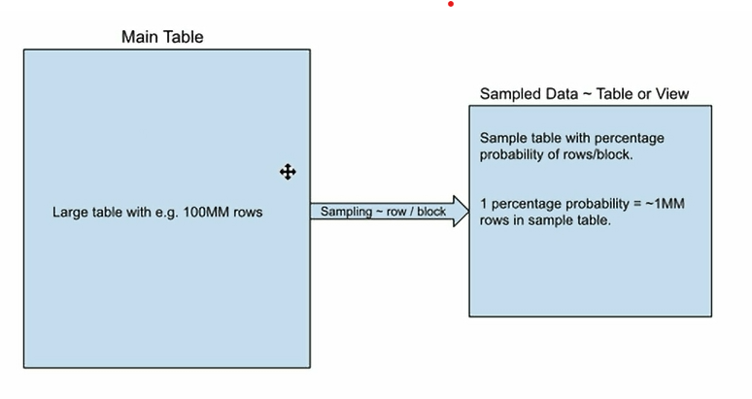
Sampling can be done in two methods
1. Row or Bernoulli method
2. System or Block method
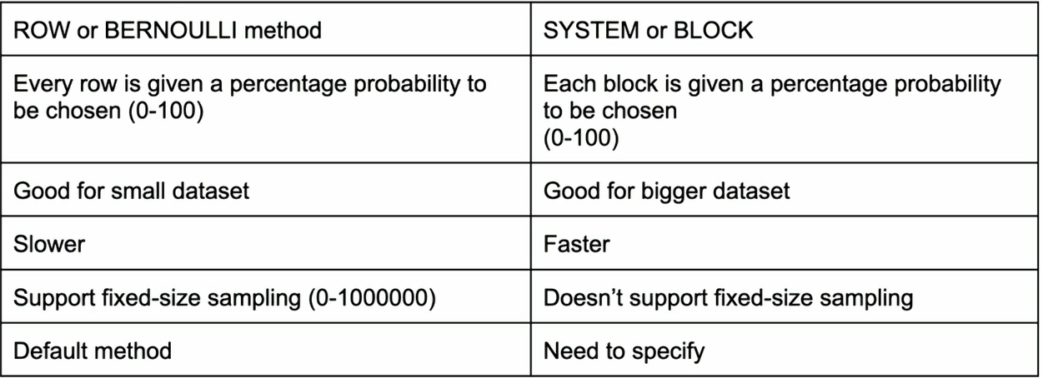

Syntax:
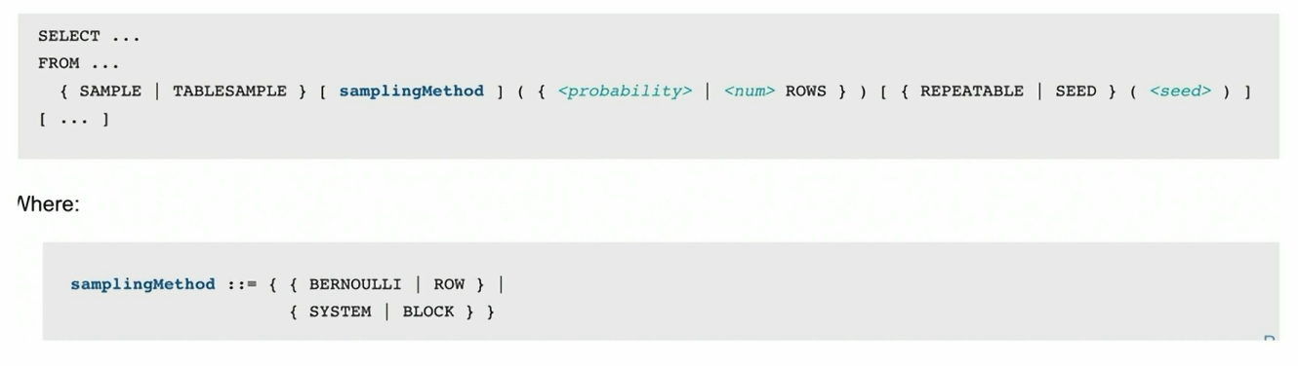
Seed/Repeatable:
If you have generated the sampling data, using keyword either SEED or REPEATABLE, giving a number between 0 – 2147483647, when you rerun it you will get the same data set.
If you rerun with same seed number, the same data you get every time
Let’s do some hand’s on
Case1: Row sampling method
Let us consider a table from snowflake sample data having 100 million records
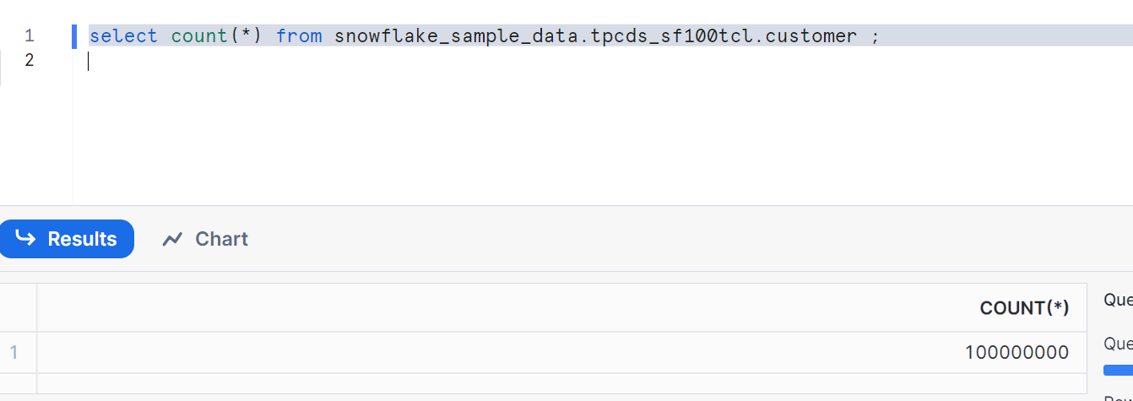
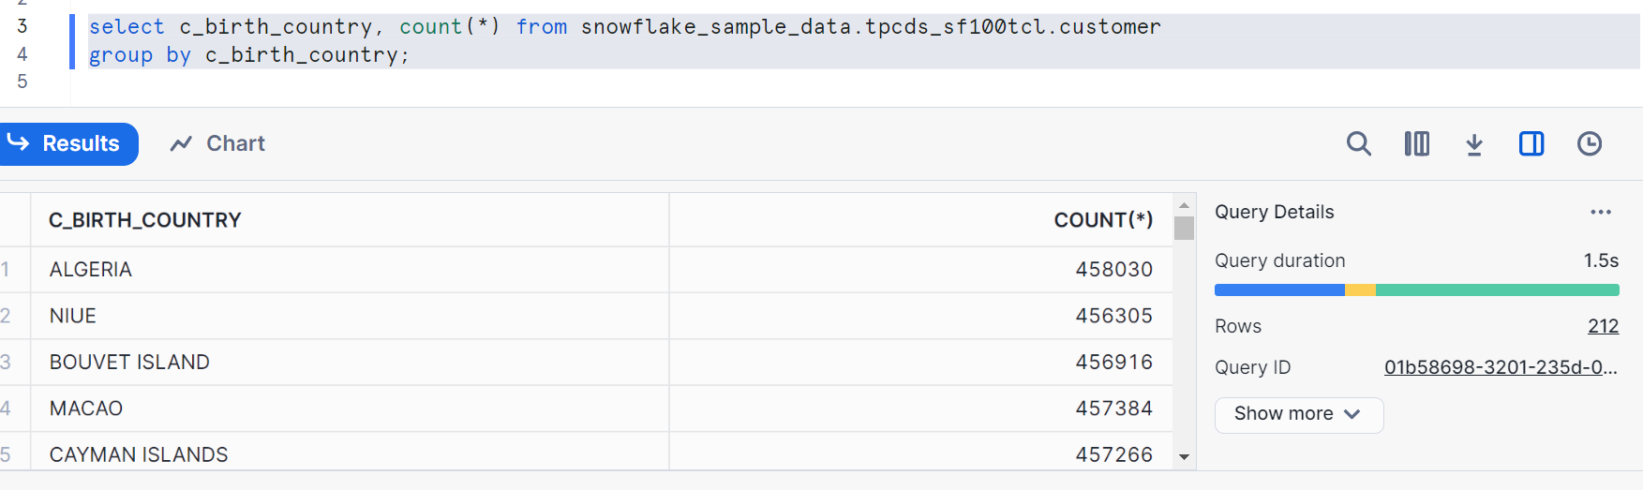
Now, sampling data using row method with 1 percent probability
Creating a table
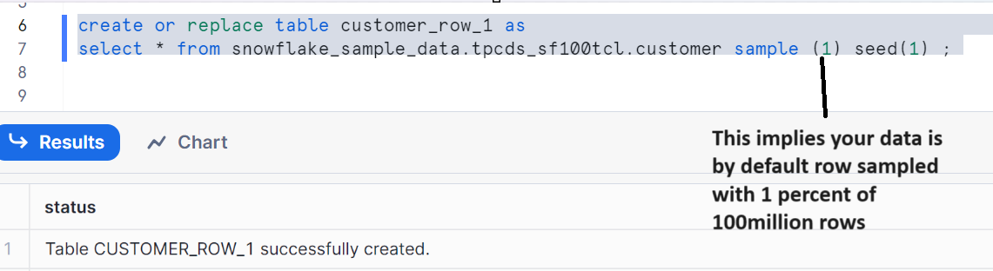
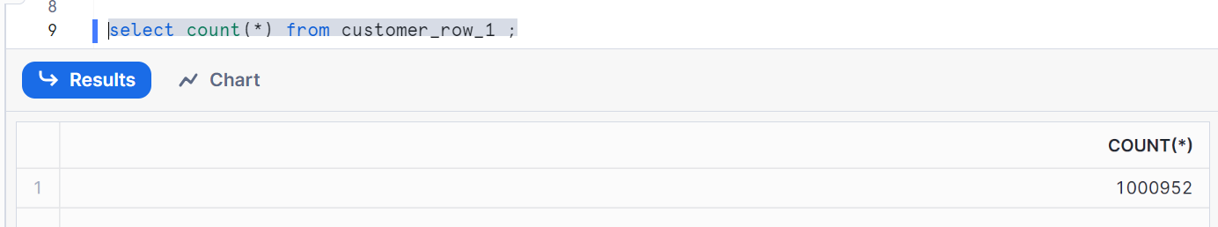
Let’s create another table by specifying row method
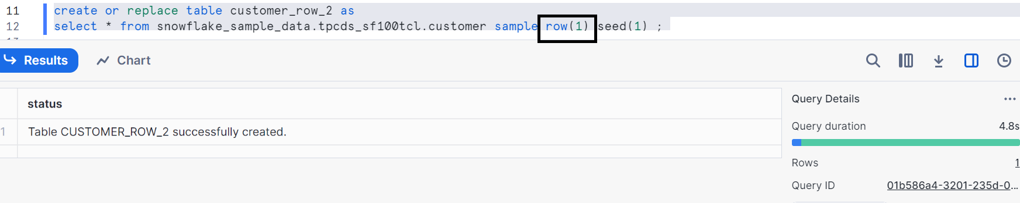
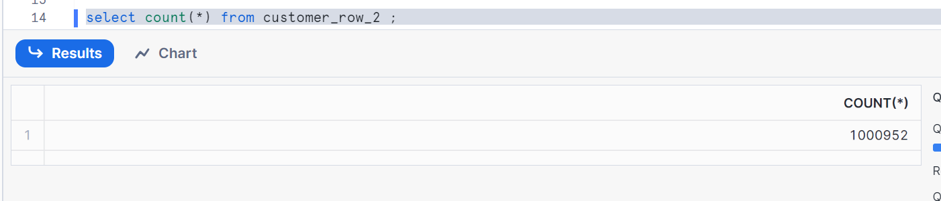

Let’s check and see
We are getting almost the 1% of records from the main table
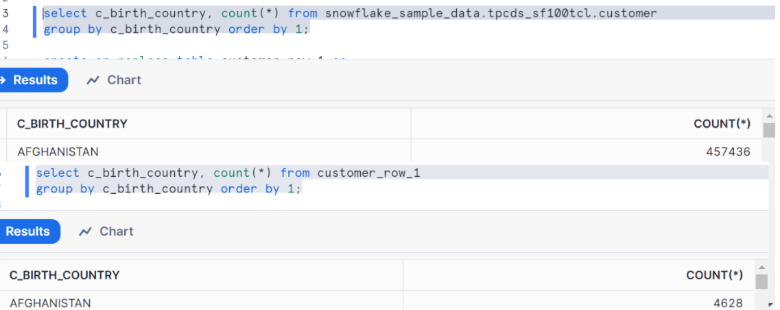

Let’s prove the seed
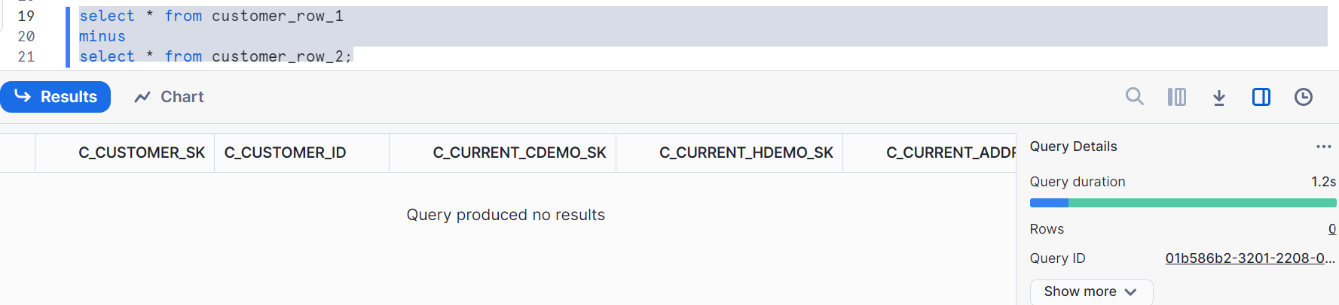
As there are no non matching records
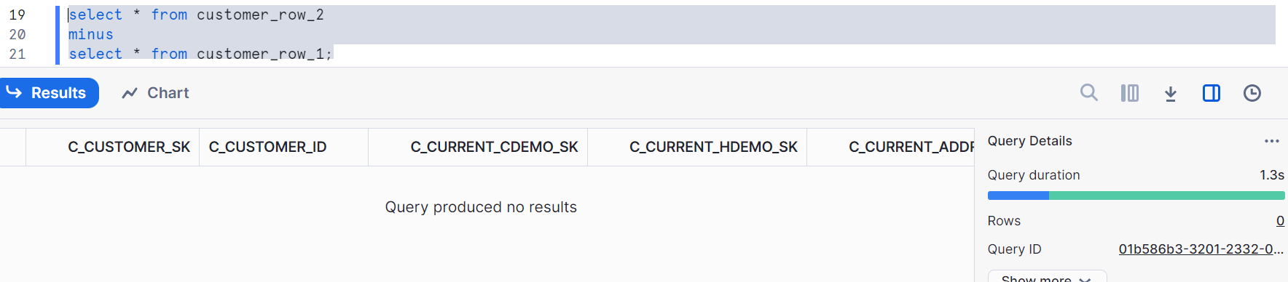
Therefore seed (1) generated identical output with all matching records

Let’s change the seed
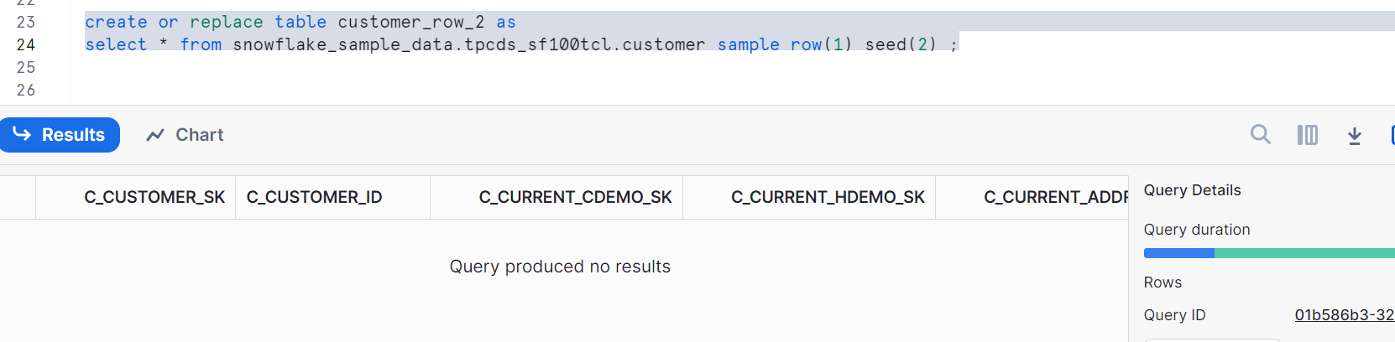
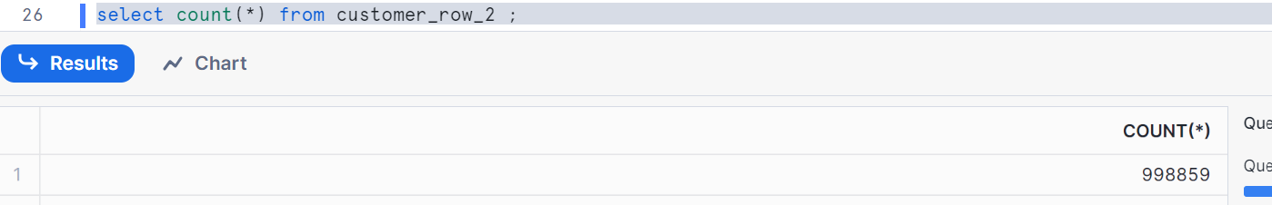
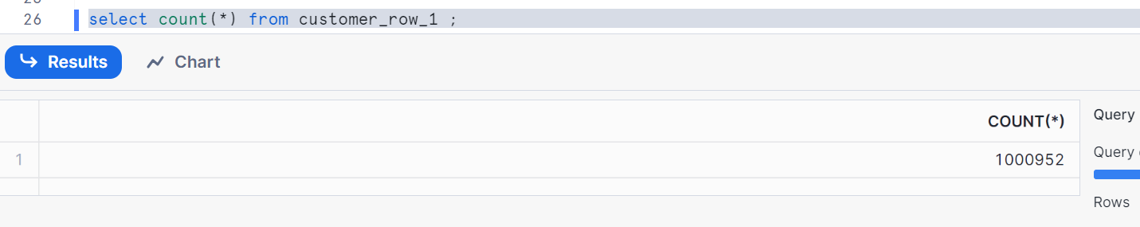
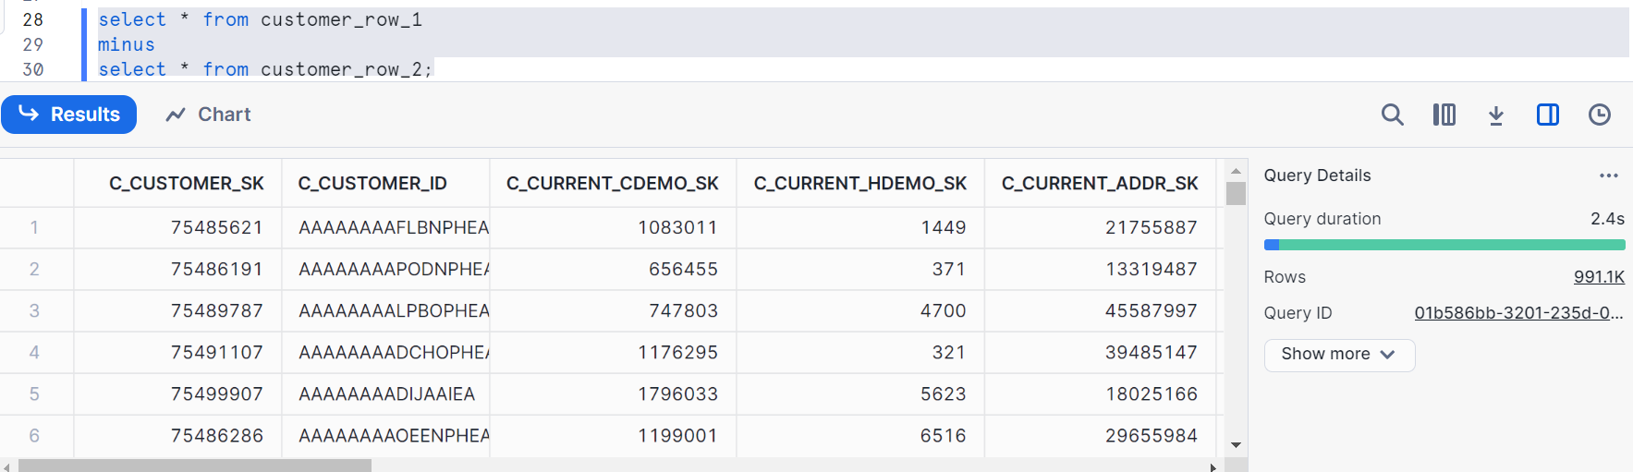
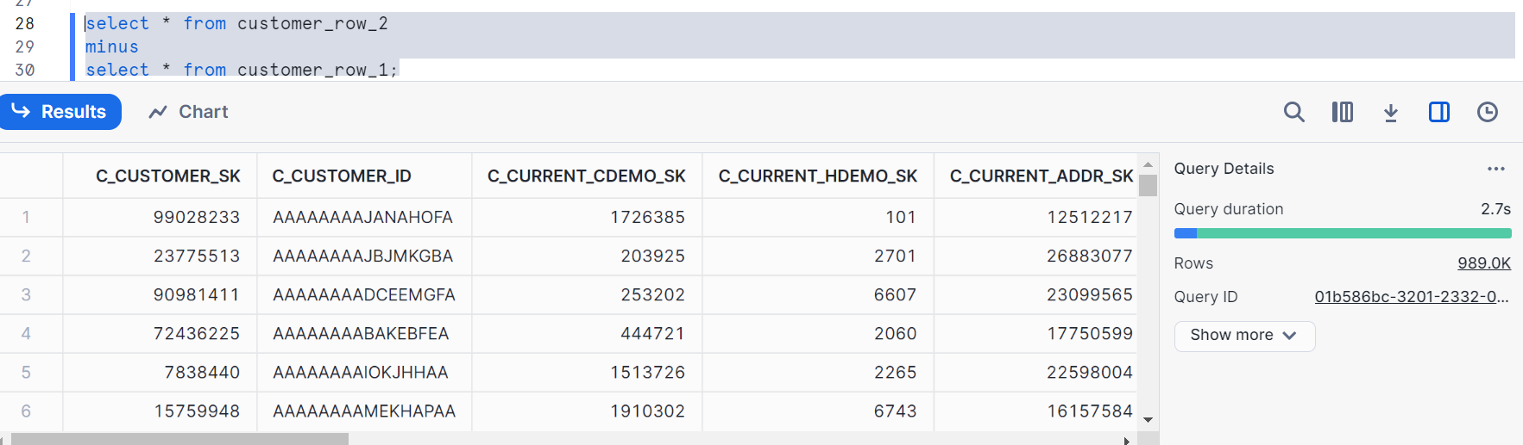
There are 991.1k records and 989k that are non-matching between both tables
Now, let’s change percentage probability from 1 to 25 by creating new table
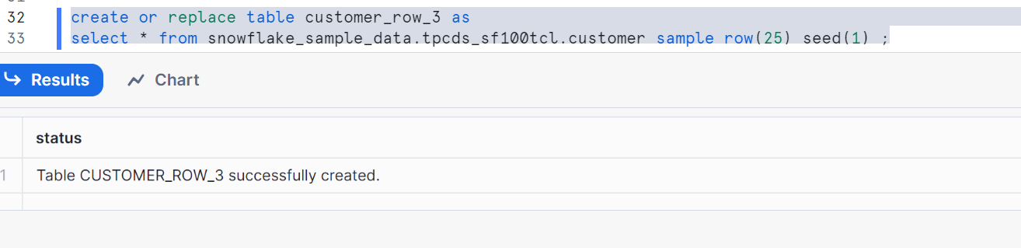
We have to get 25% records from main table i.e. 25 million records approx.
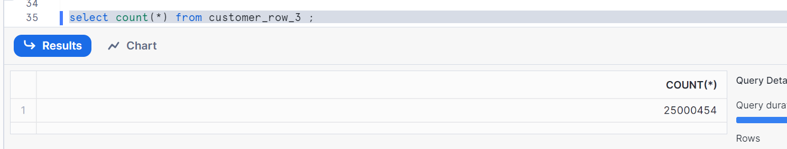
Run the below query so that the output you get is approximately 25% of the count from main count in each country
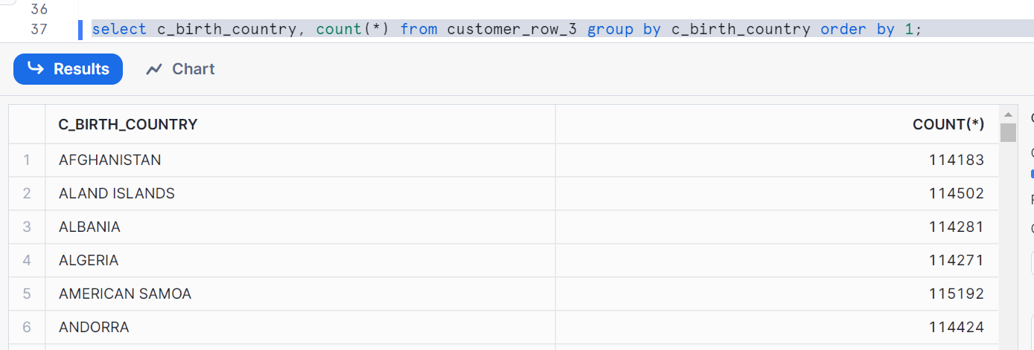

Fixed Size sampling implies instead of providing percentage, we give number of records
Let’s see
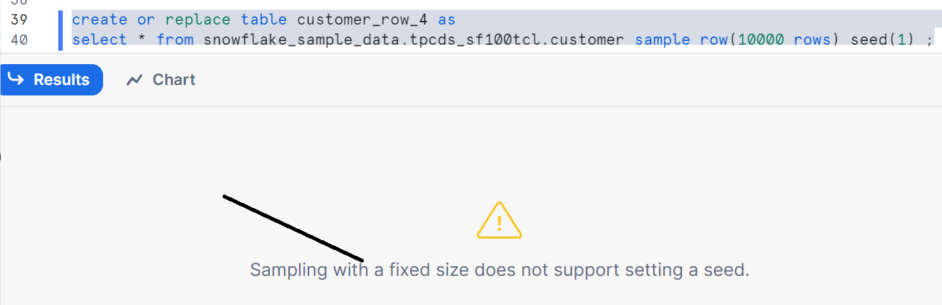
Seed not supported with row fixed sampling

Therefore let’s remove the seed and create table
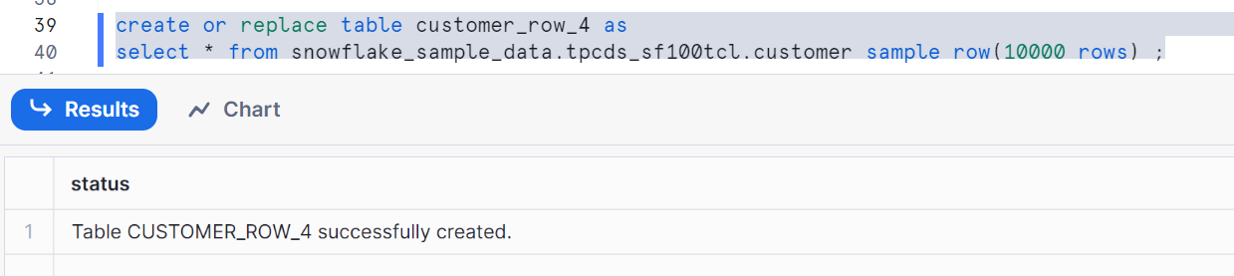
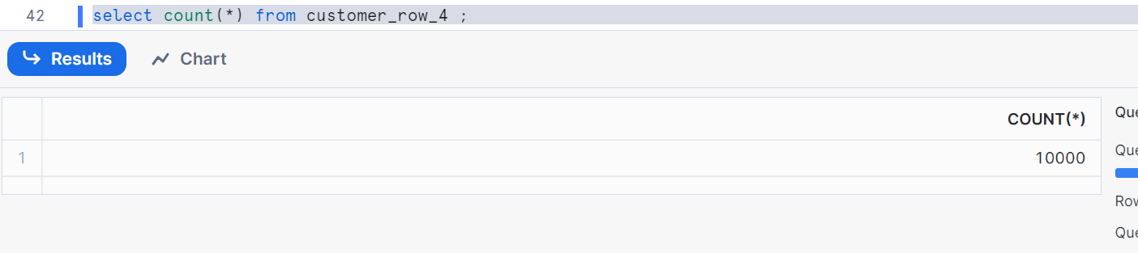
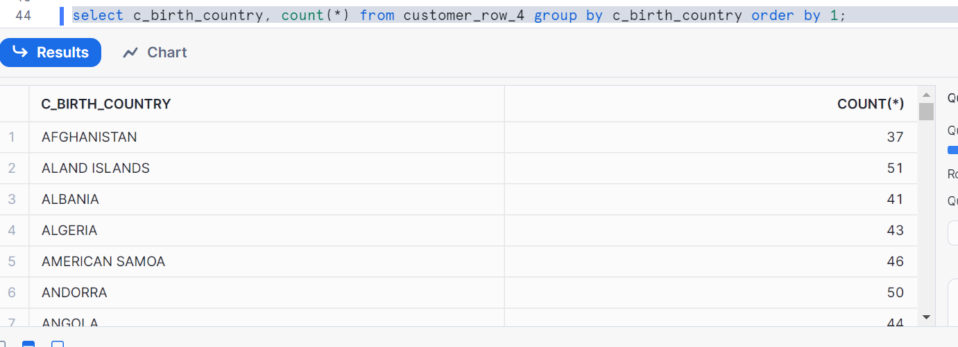
This implies almost 0.01% count compared to main table count

Case2: SYSTEM/BLOCK method
Let’s create a table with System/Block method with 1 percentage probability with seed (1)
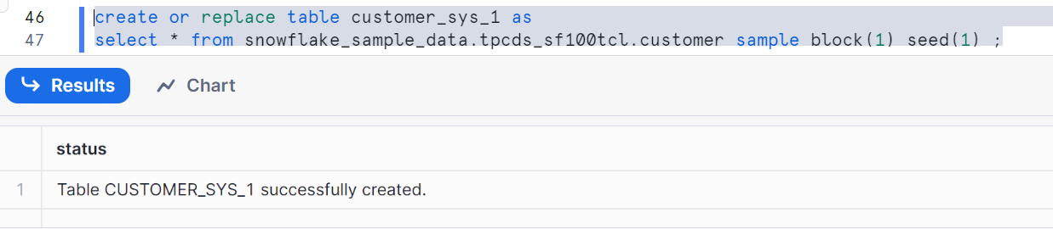
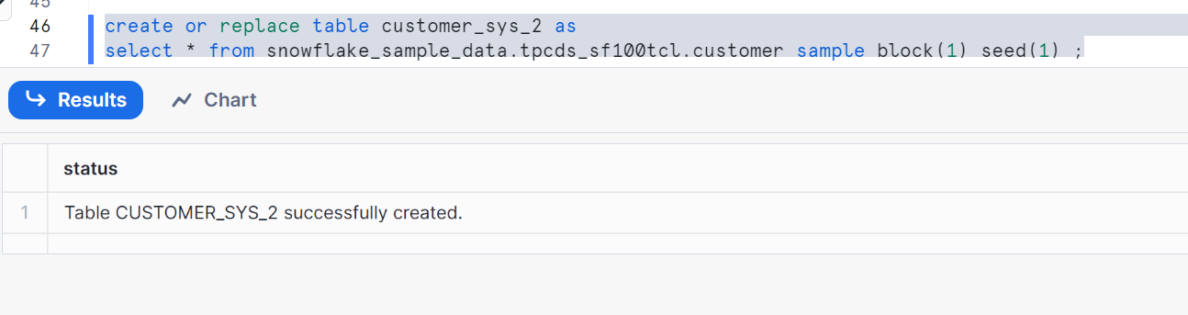
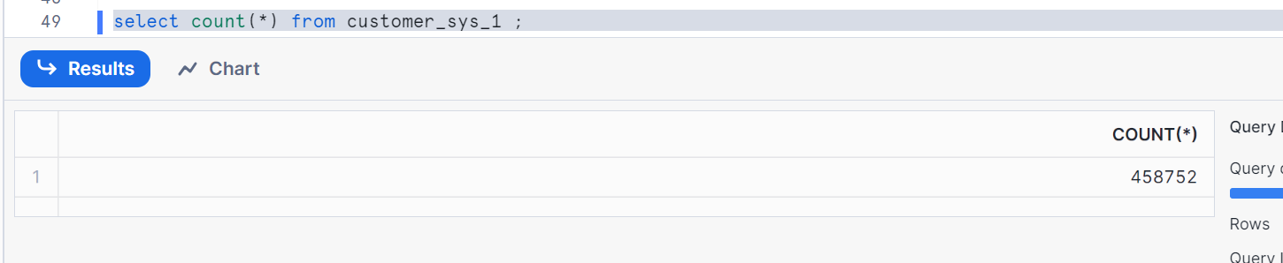
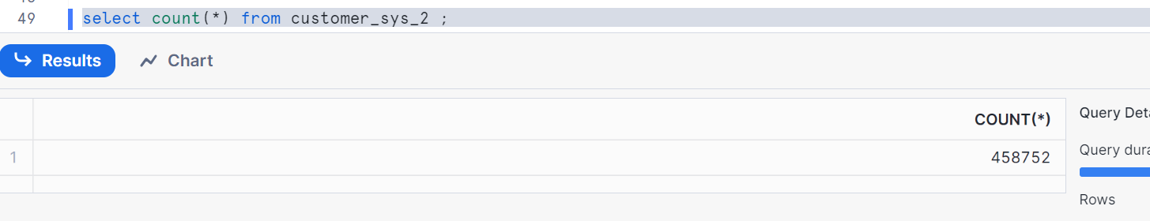
Let’s prove seed and system/block
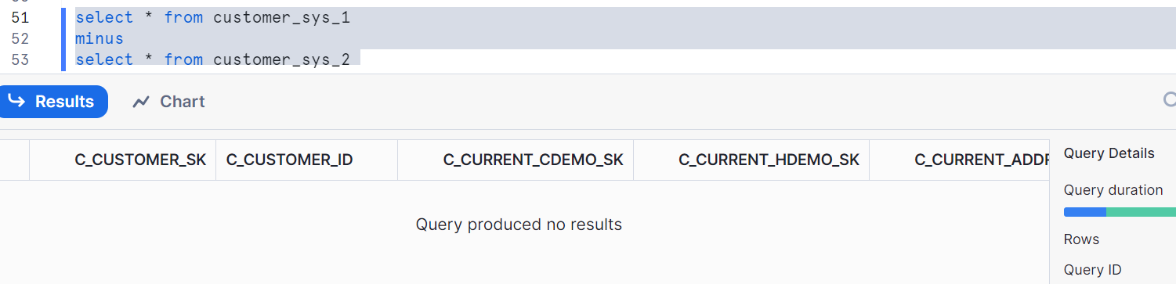
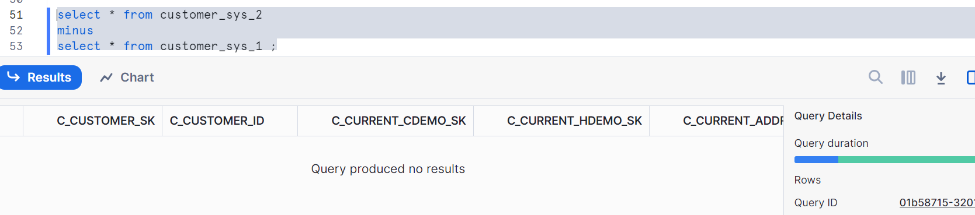

Now let’s recreate table 2 with seed (2)
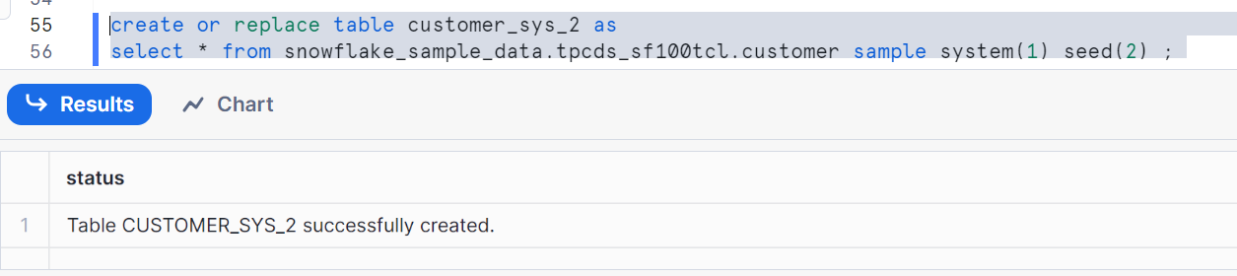
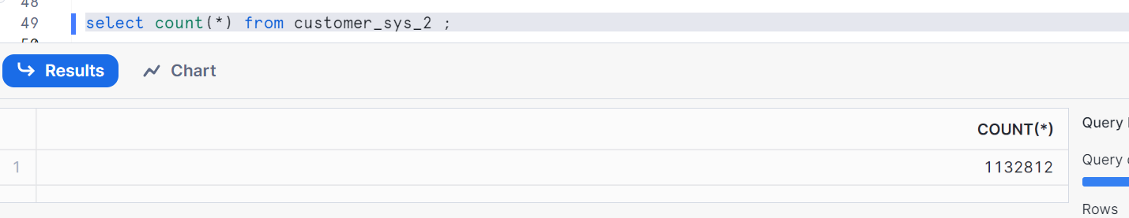
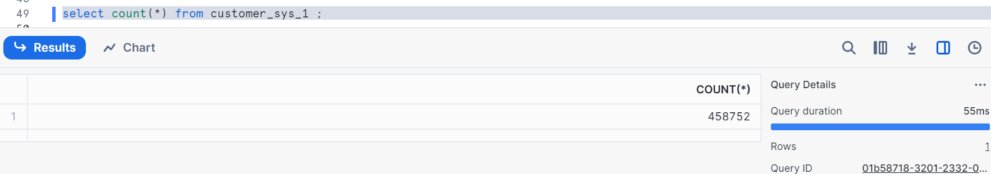
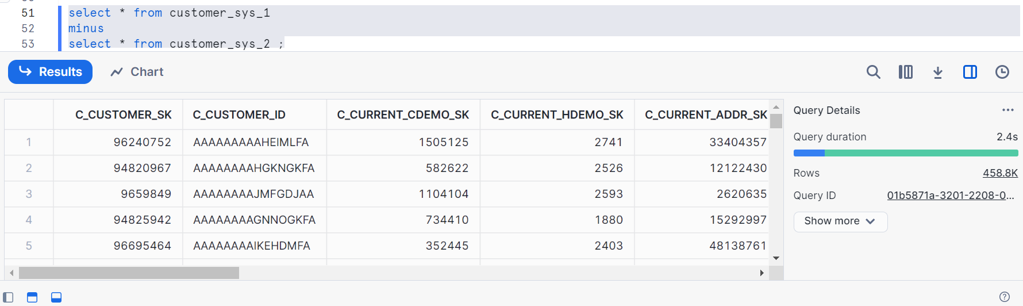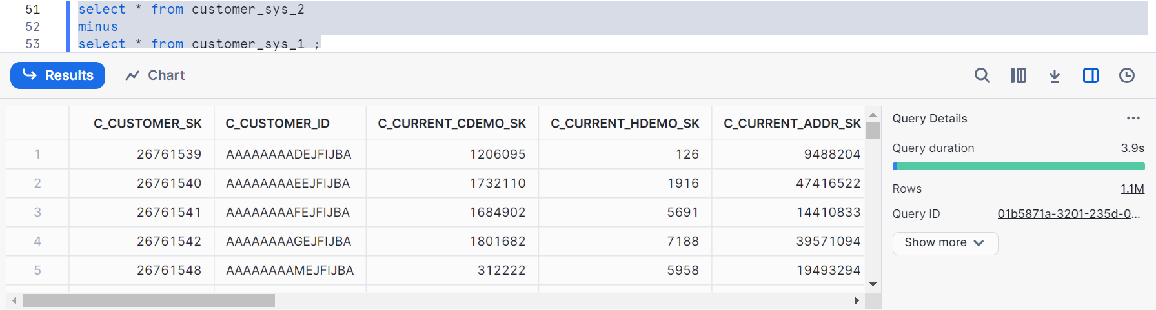
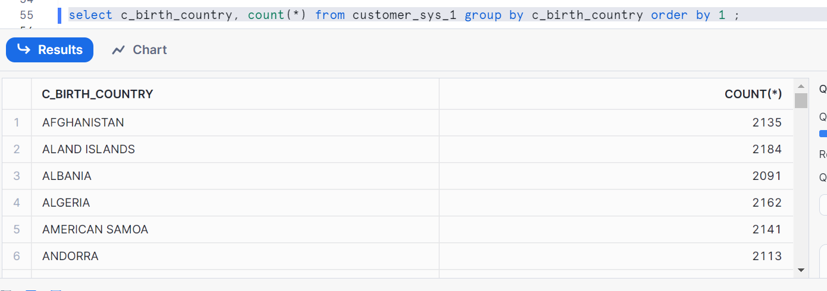
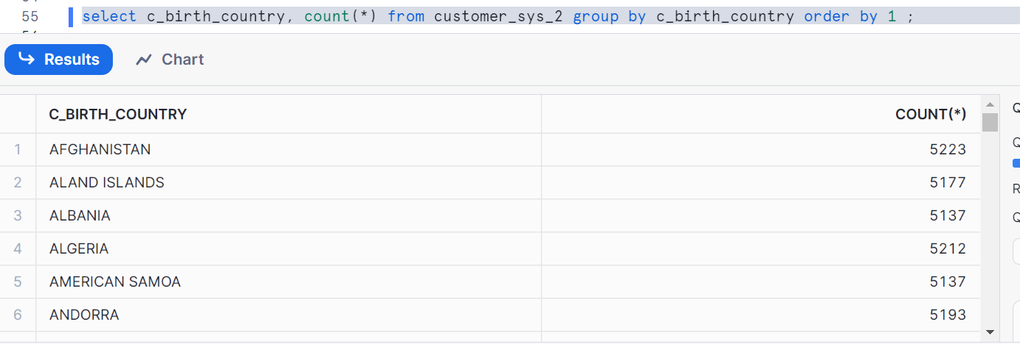
Let’s change percentage probability change from 1 to 25
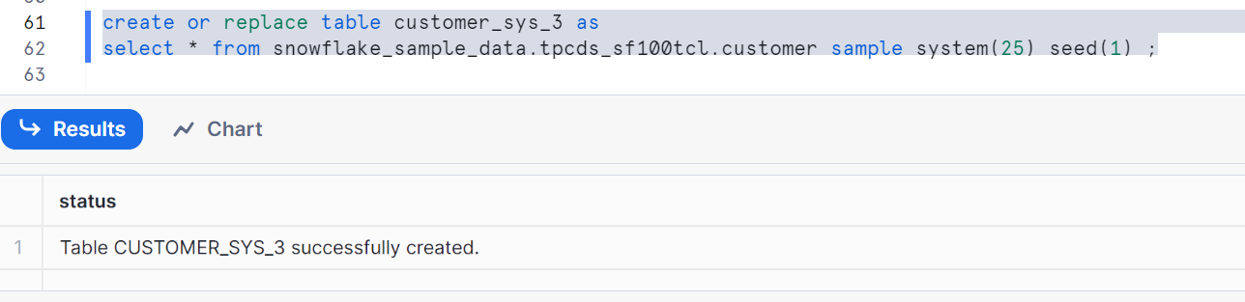
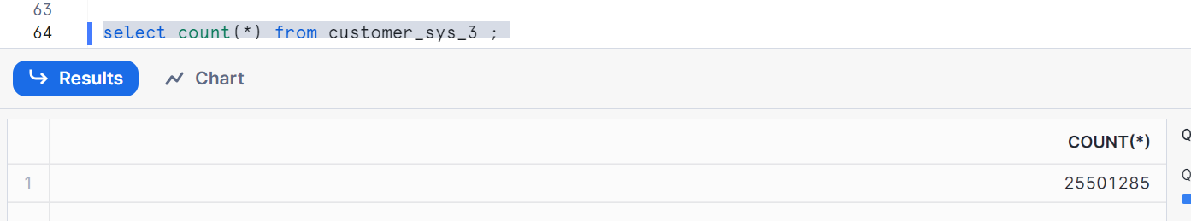
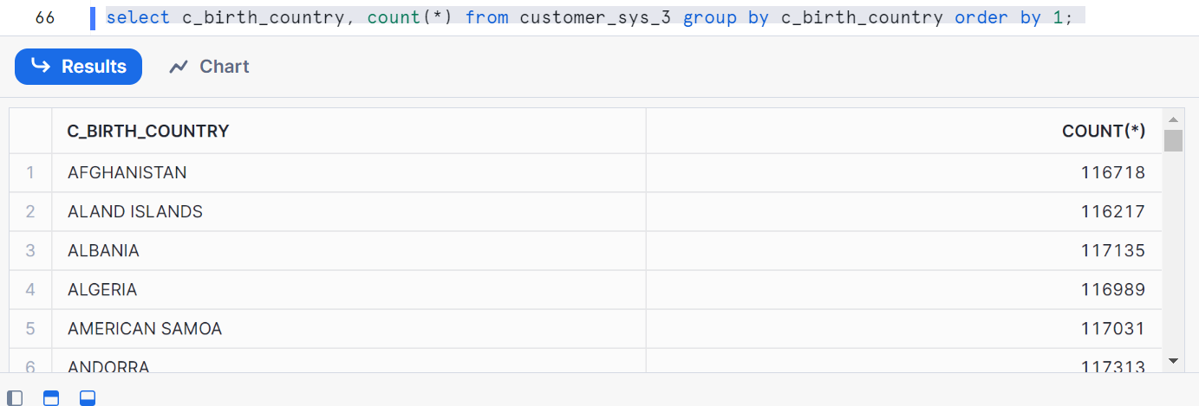

Fixed Size sampling
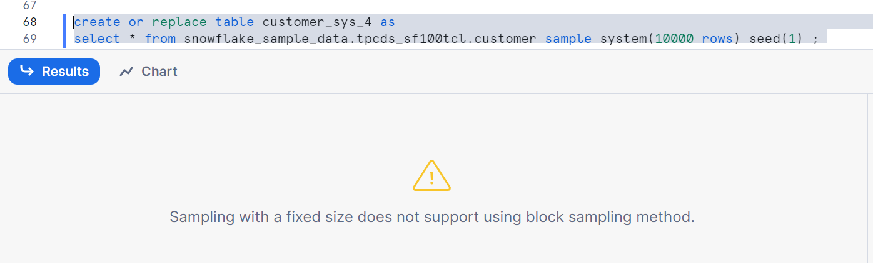Seed not supported in block sampling as we have seen in previous case with row fixed size sampling
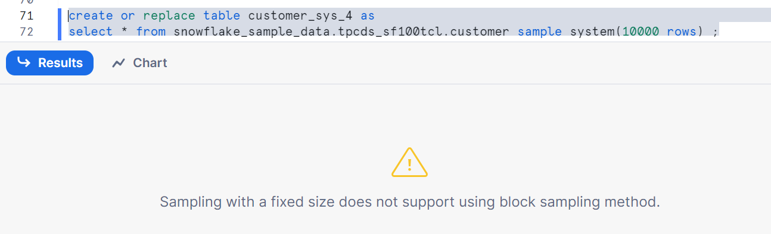
Hence by removing seed also, block/system fixed size sampling not supported

